Assignment 11
PNR: 260740150018
Name: PRATIK SUNIL ABHANG

Question 1:
Create a NumPy array containing 10 integers and display the array.
Program
import numpy as np
def create_array():
return np.array([10, 20, 30, 40, 50, 60, 70, 80, 90, 100])
array = create_array()
print(array)

Input and Output
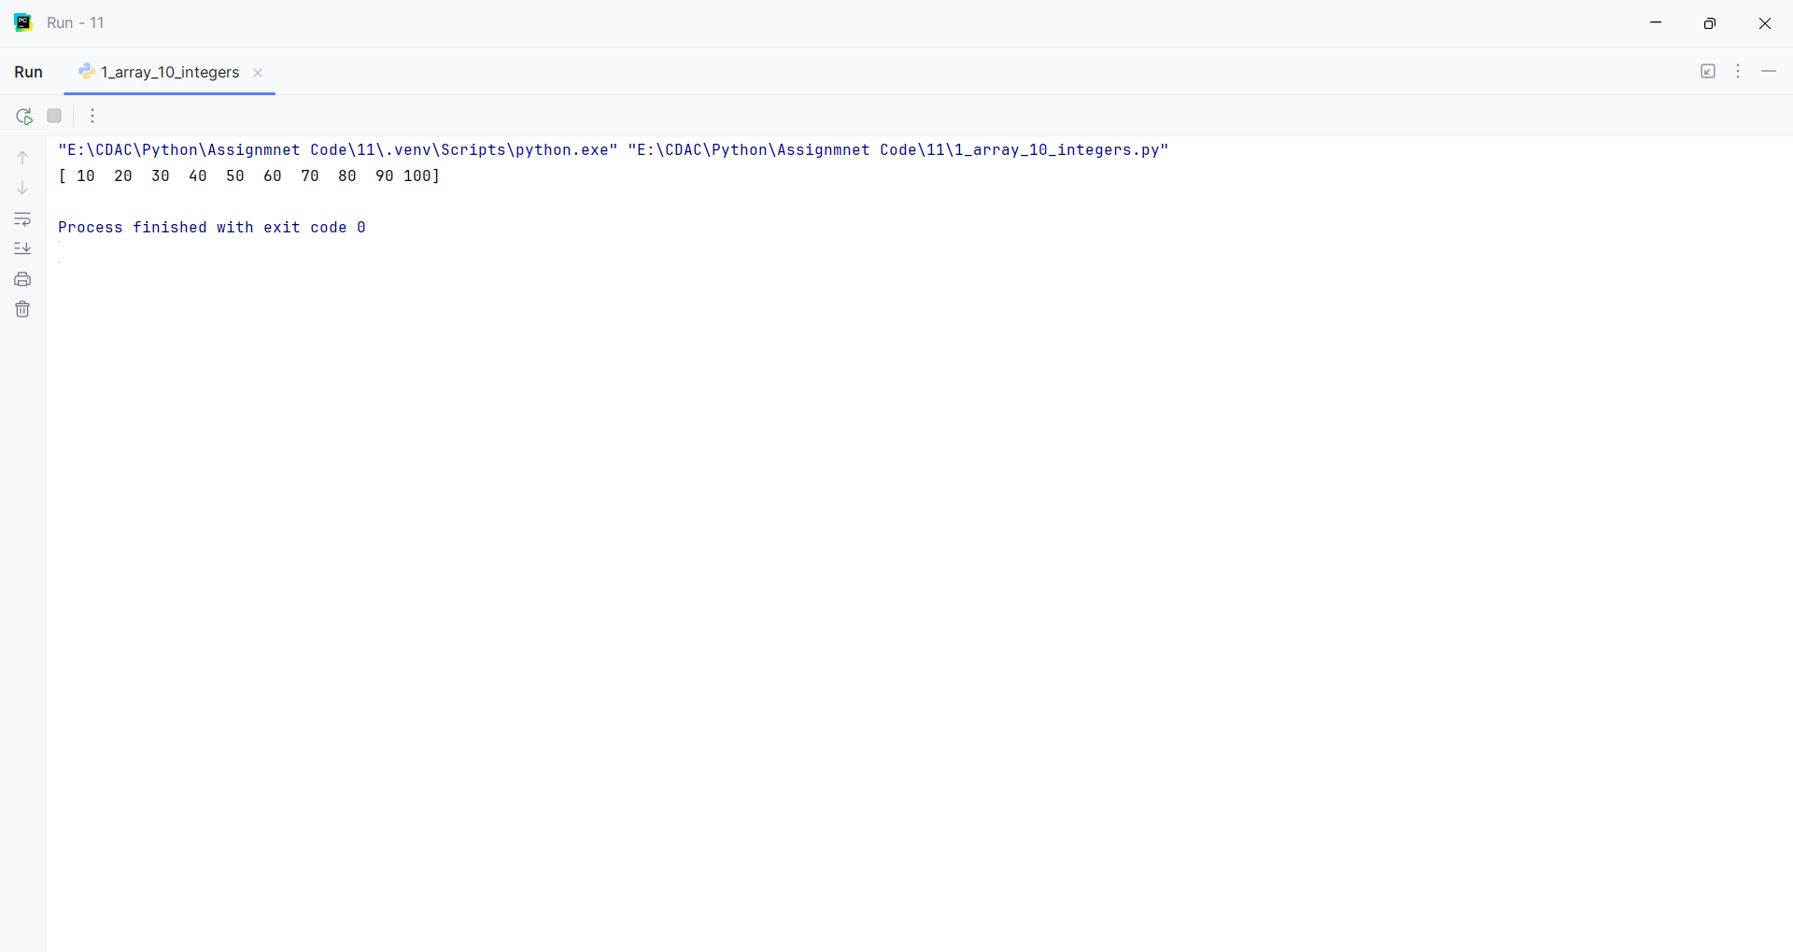
Question 2:
Create a NumPy array of numbers from 1 to 20 and find its sum, mean, maximum, and minimum.
Program
import numpy as np
def calculate_statistics():
array = np.arange(1, 21)
return array, array.sum(), array.mean(), array.max(), array.min()
array, total, mean, maximum, minimum = calculate_statistics()
print(array)
print("Sum:", total)
print("Mean:", mean)
print("Maximum:", maximum)
print("Minimum:", minimum)

Input and Output
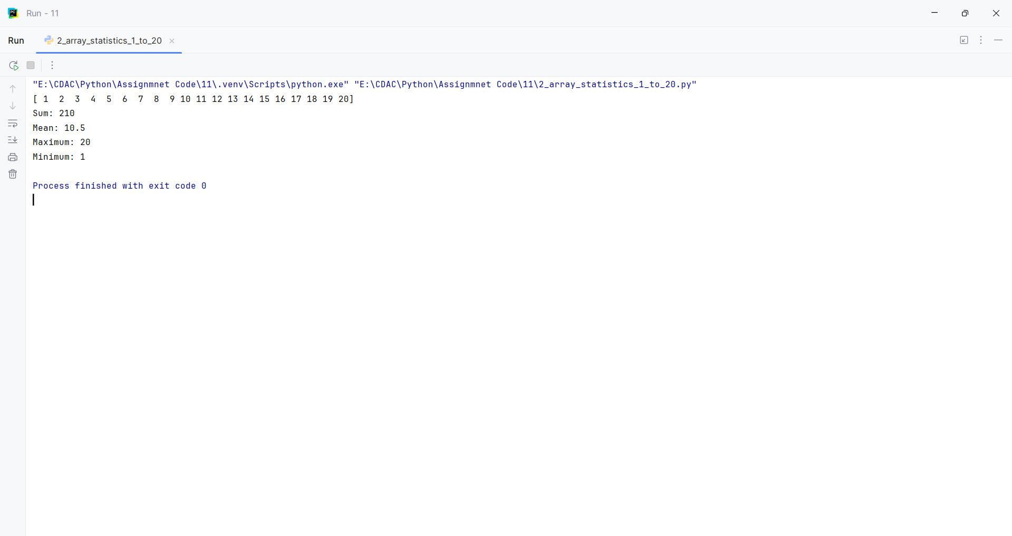
Question 3:
Create a 1-D NumPy array and perform addition, subtraction, multiplication, and division on its elements.
Program
import numpy as np
def perform_operations():
array = np.array([10, 20, 30, 40, 50])
return array + 5, array - 5, array * 2, array / 2
addition, subtraction, multiplication, division = perform_operations()
print("Addition:", addition)
print("Subtraction:", subtraction)
print("Multiplication:", multiplication)
print("Division:", division)

Input and Output
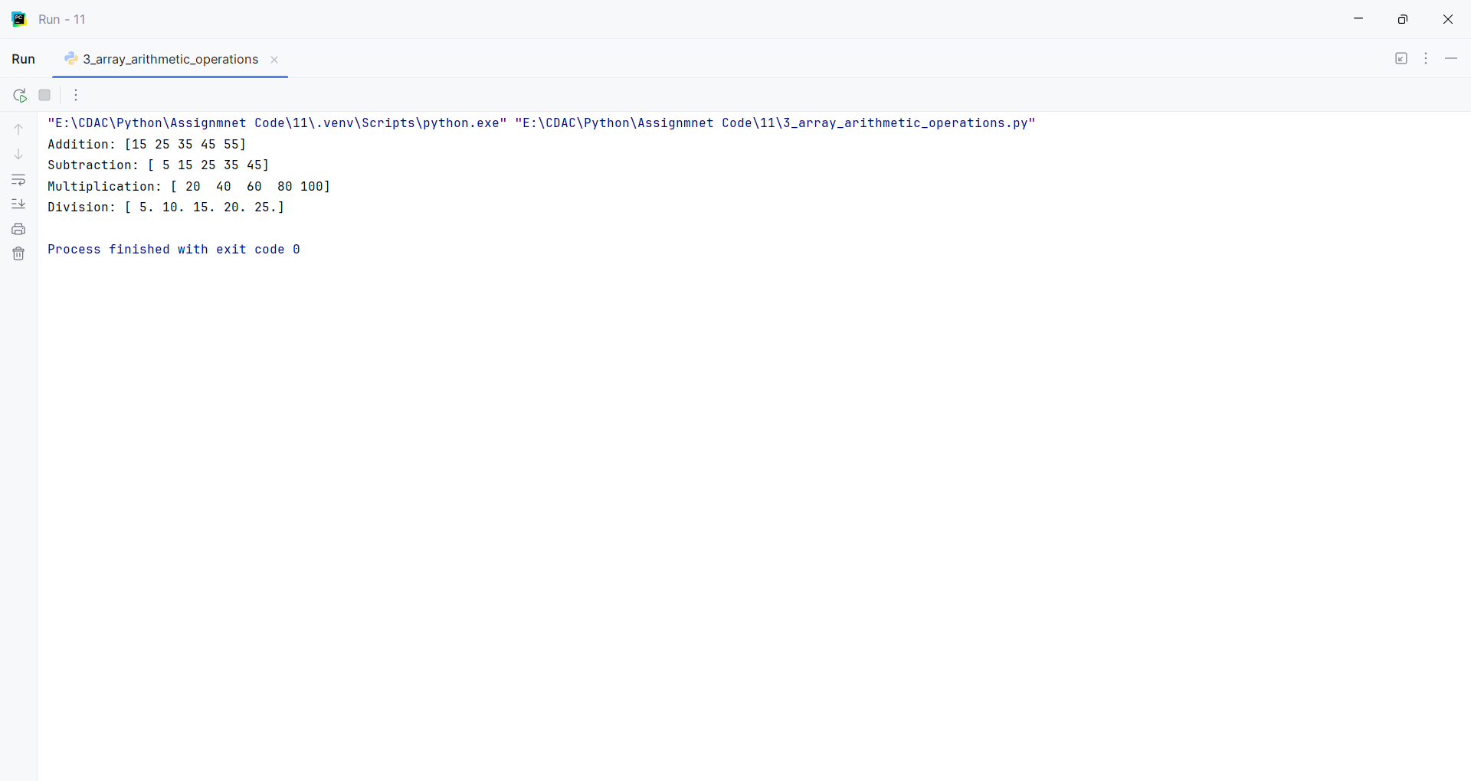
Question 4:
Create a 3×3 NumPy matrix and display its rows and columns.
Program
import numpy as np
def create_matrix():
matrix = np.arange(1, 10).reshape(3, 3)
return matrix
matrix = create_matrix()
print(matrix)
for row in matrix:
print("Row:", row)
for column in matrix.T:
print("Column:", column)

Input and Output
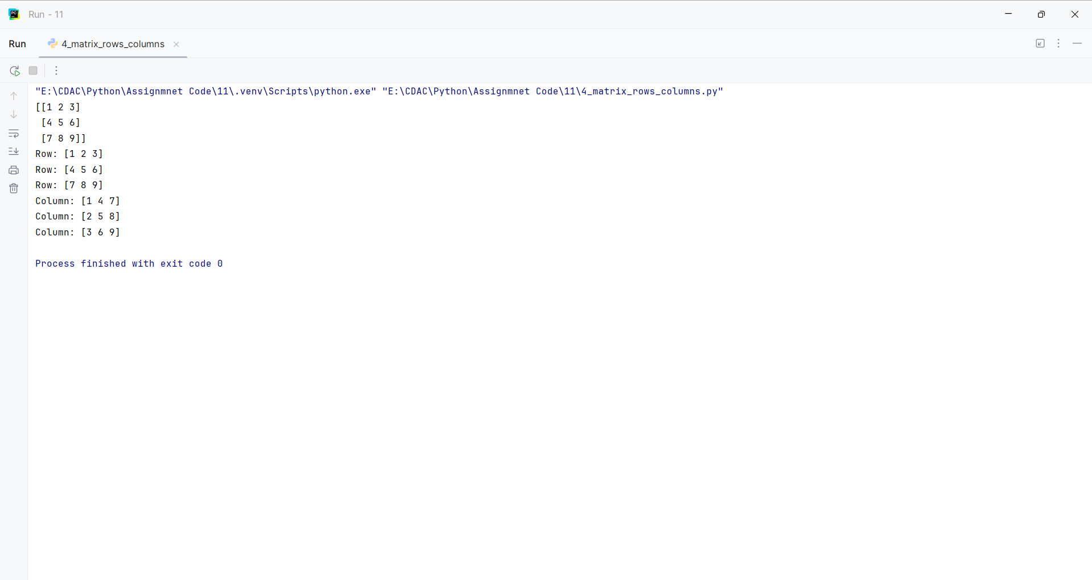
Question 5:
Create a NumPy array and find its shape, size, and data type.
Program
import numpy as np
def array_properties():
array = np.array([[10, 20, 30], [40, 50, 60]])
return array, array.shape, array.size, array.dtype
array, shape, size, dtype = array_properties()
print(array)
print("Shape:", shape)
print("Size:", size)
print("Data type:", dtype)

Input and Output
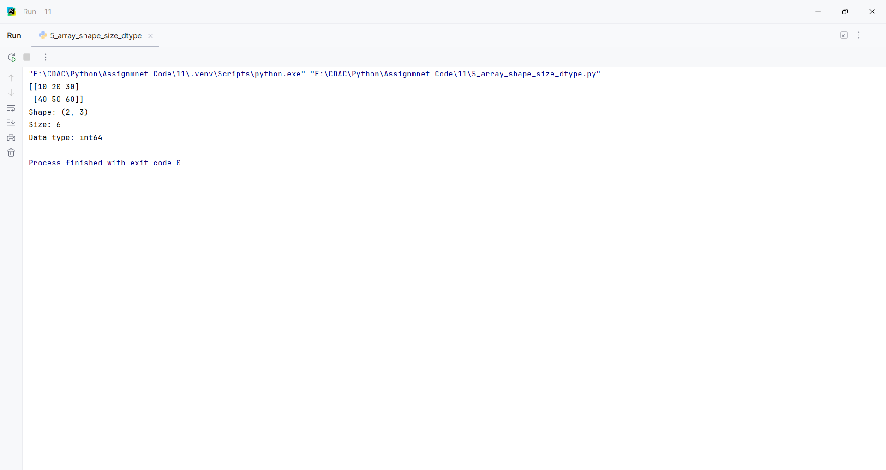
Question 6:
Create an array of 10 zeros and another array of 10 ones using NumPy.
Program
import numpy as np
def create_arrays():
return np.zeros(10, dtype=int), np.ones(10, dtype=int)
zeros, ones = create_arrays()
print("Zeros:", zeros)
print("Ones:", ones)

Input and Output
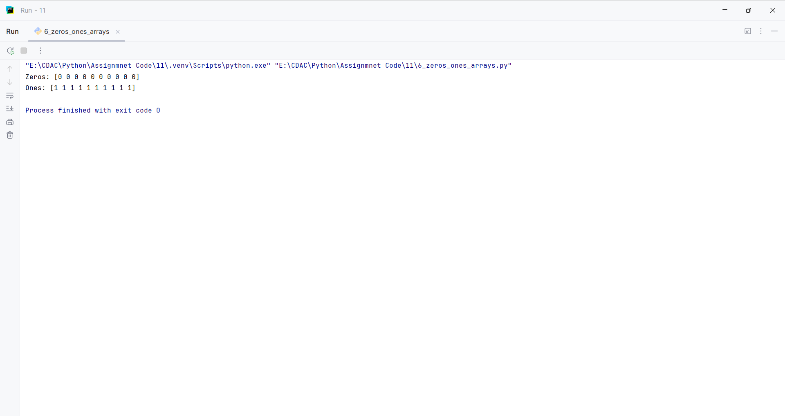
Question 7:
Create a NumPy array containing even numbers from 2 to 20.
Program
import numpy as np
def create_even_array():
return np.arange(2, 21, 2)
print(create_even_array())

Input and Output
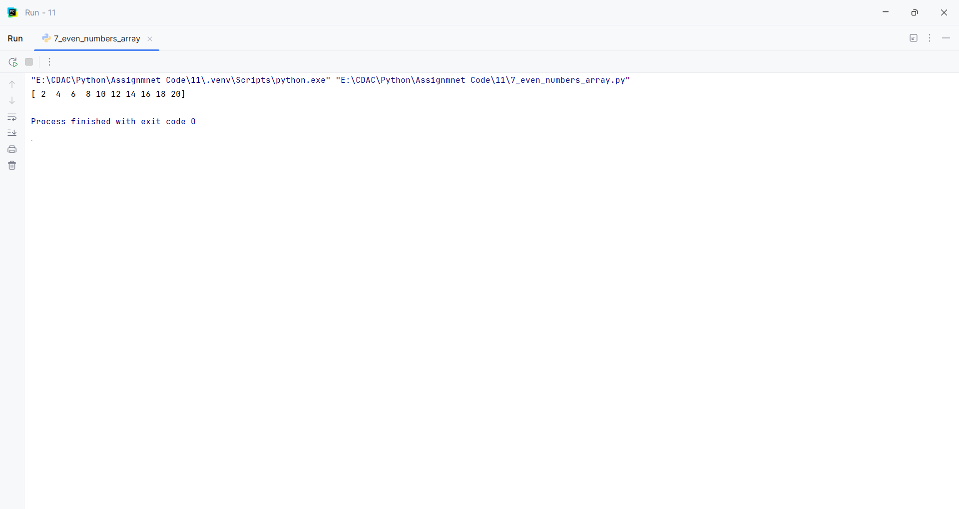
Question 8:
Create a 3×3 NumPy array and calculate the sum of each row and each column.
Program
import numpy as np
def calculate_sums():
matrix = np.arange(1, 10).reshape(3, 3)
return matrix, matrix.sum(axis=1), matrix.sum(axis=0)
matrix, row_sum, column_sum = calculate_sums()
print(matrix)
print("Row sums:", row_sum)
print("Column sums:", column_sum)

Input and Output
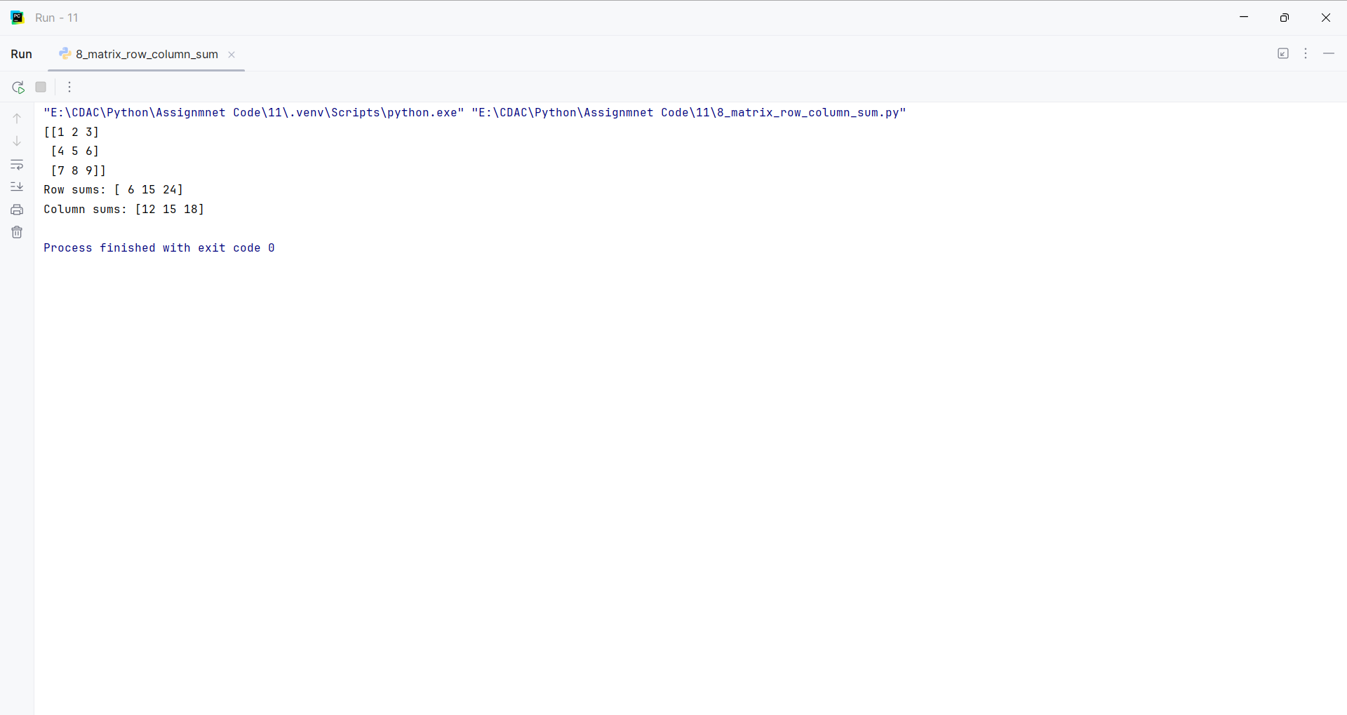
Question 9:
Create two NumPy arrays and perform element-wise addition and multiplication.
Program
import numpy as np
def array_operations():
first = np.array([1, 2, 3, 4, 5])
second = np.array([10, 20, 30, 40, 50])
return first + second, first * second
addition, multiplication = array_operations()
print("Addition:", addition)
print("Multiplication:", multiplication)

Input and Output
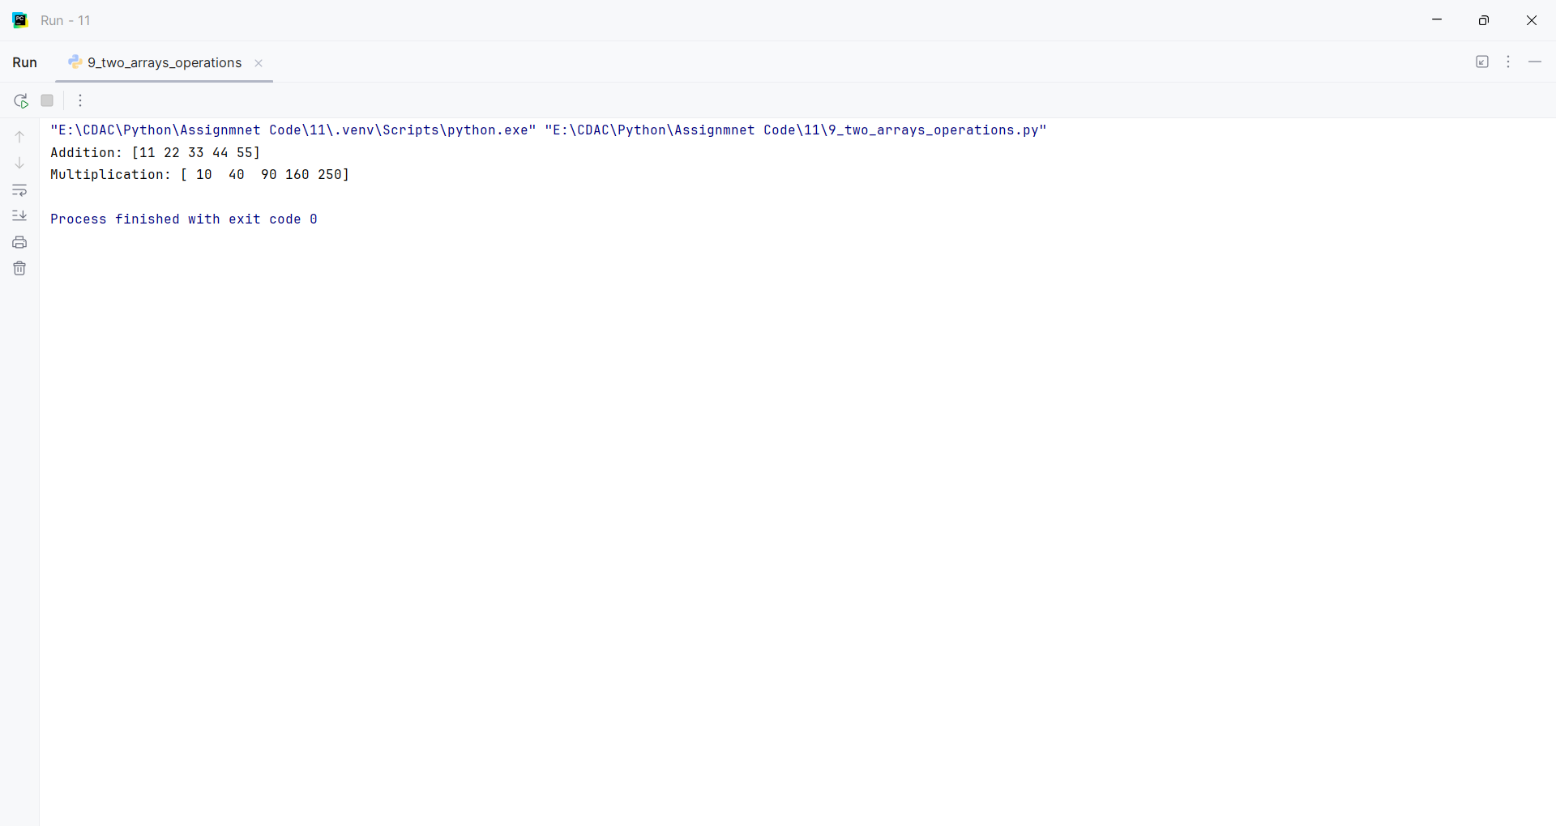
Question 10:
Create a NumPy array and sort its elements in ascending and descending order.
Program
import numpy as np
def sort_array():
array = np.array([45, 12, 78, 23, 56, 9])
ascending = np.sort(array)
descending = np.sort(array)[::-1]
return ascending, descending
ascending, descending = sort_array()
print("Ascending:", ascending)
print("Descending:", descending)

Input and Output
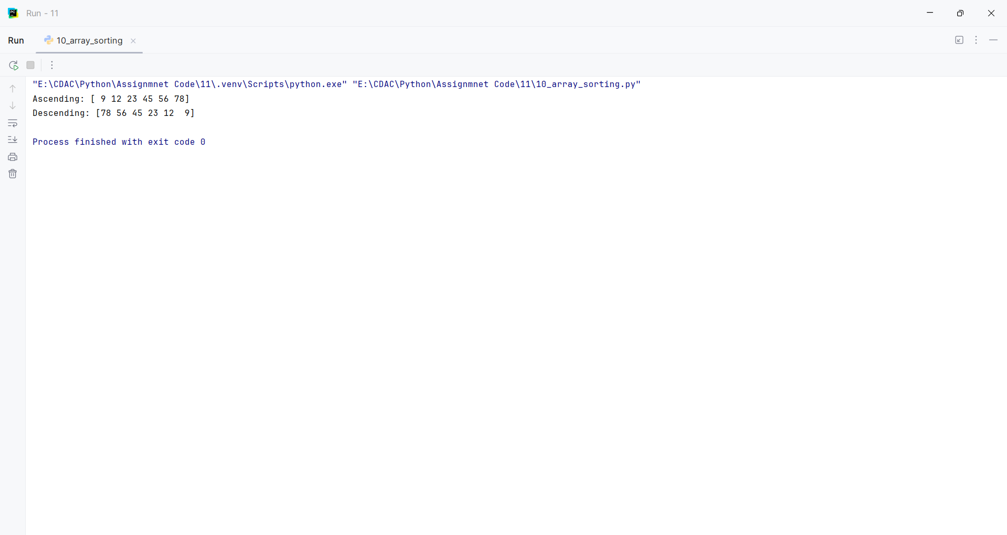
Question 11:
Create a NumPy array and replace all elements greater than 50 with 0.
Program
import numpy as np
def replace_values():
array = np.array([10, 55, 30, 70, 45, 90])
array[array > 50] = 0
return array
print(replace_values())

Input and Output
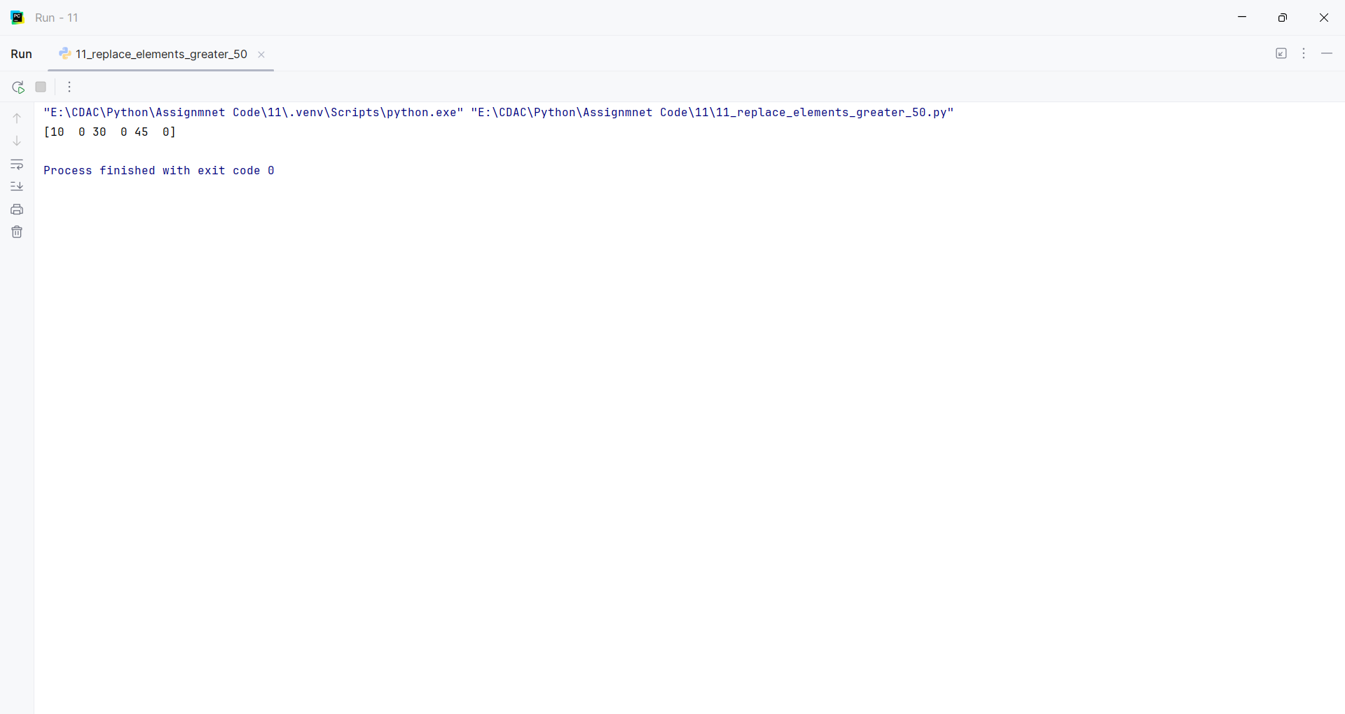
Question 12:
Create a NumPy array of student marks and find the highest, lowest, and average marks.
Program
import numpy as np
def marks_statistics():
marks = np.array([78, 85, 92, 67, 88])
return marks, marks.max(), marks.min(), marks.mean()
marks, highest, lowest, average = marks_statistics()
print("Marks:", marks)
print("Highest:", highest)
print("Lowest:", lowest)
print("Average:", average)

Input and Output
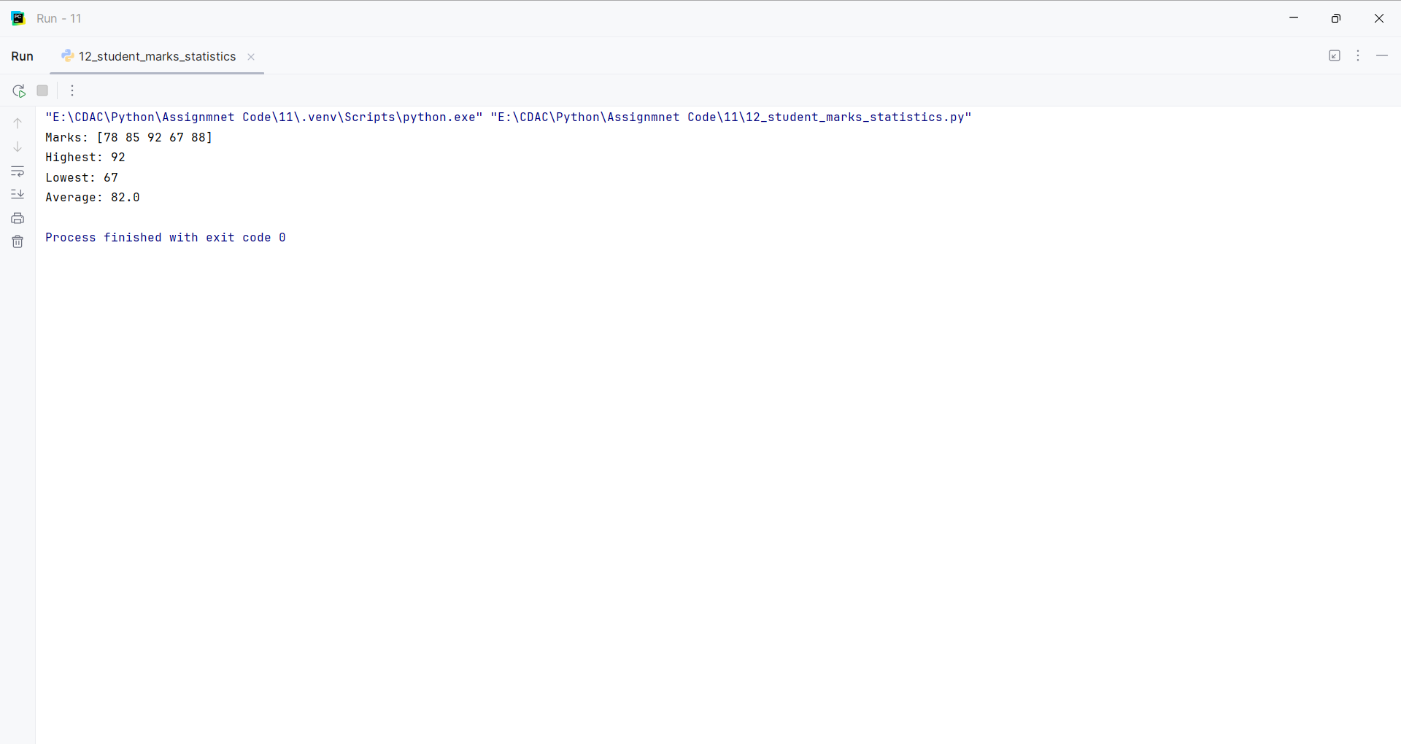
Question 13:
Create a DataFrame from a dictionary containing employee name, department, and salary, and display the first 5 records.
Program
import pandas as pd
def create_dataframe():
data = {"Name": ["A", "B", "C", "D", "E", "F"], "Department": ["IT", "HR", "Sales", "IT", "HR", "Sales"], "Salary": [50000, 45000, 55000, 60000, 47000, 52000]}
return pd.DataFrame(data)
df = create_dataframe()
print(df.head())

Input and Output
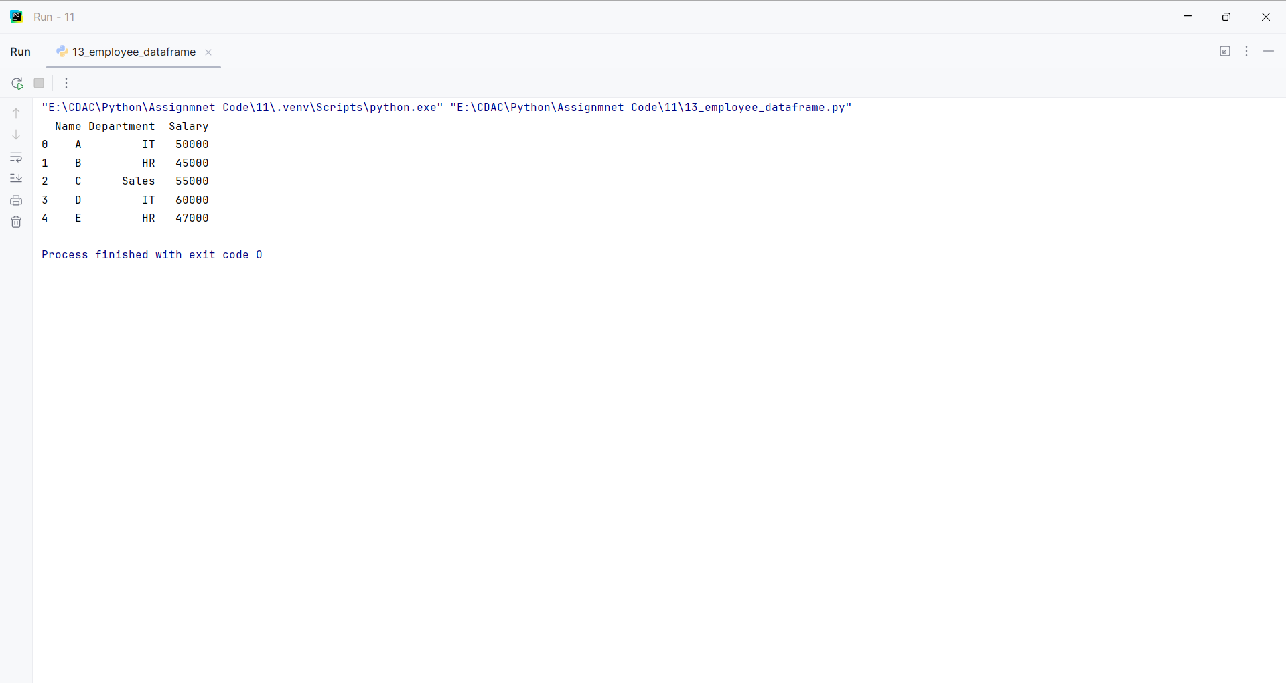
Question 14:
Create a DataFrame and display its shape, columns, data types, and size.
Program
import pandas as pd
def dataframe_properties():
return pd.DataFrame({"Name": ["A", "B", "C"], "Marks": [70, 80, 90]})
df = dataframe_properties()
print("Shape:", df.shape)
print("Columns:", list(df.columns))
print("Data types:", df.dtypes)
print("Size:", df.size)

Input and Output
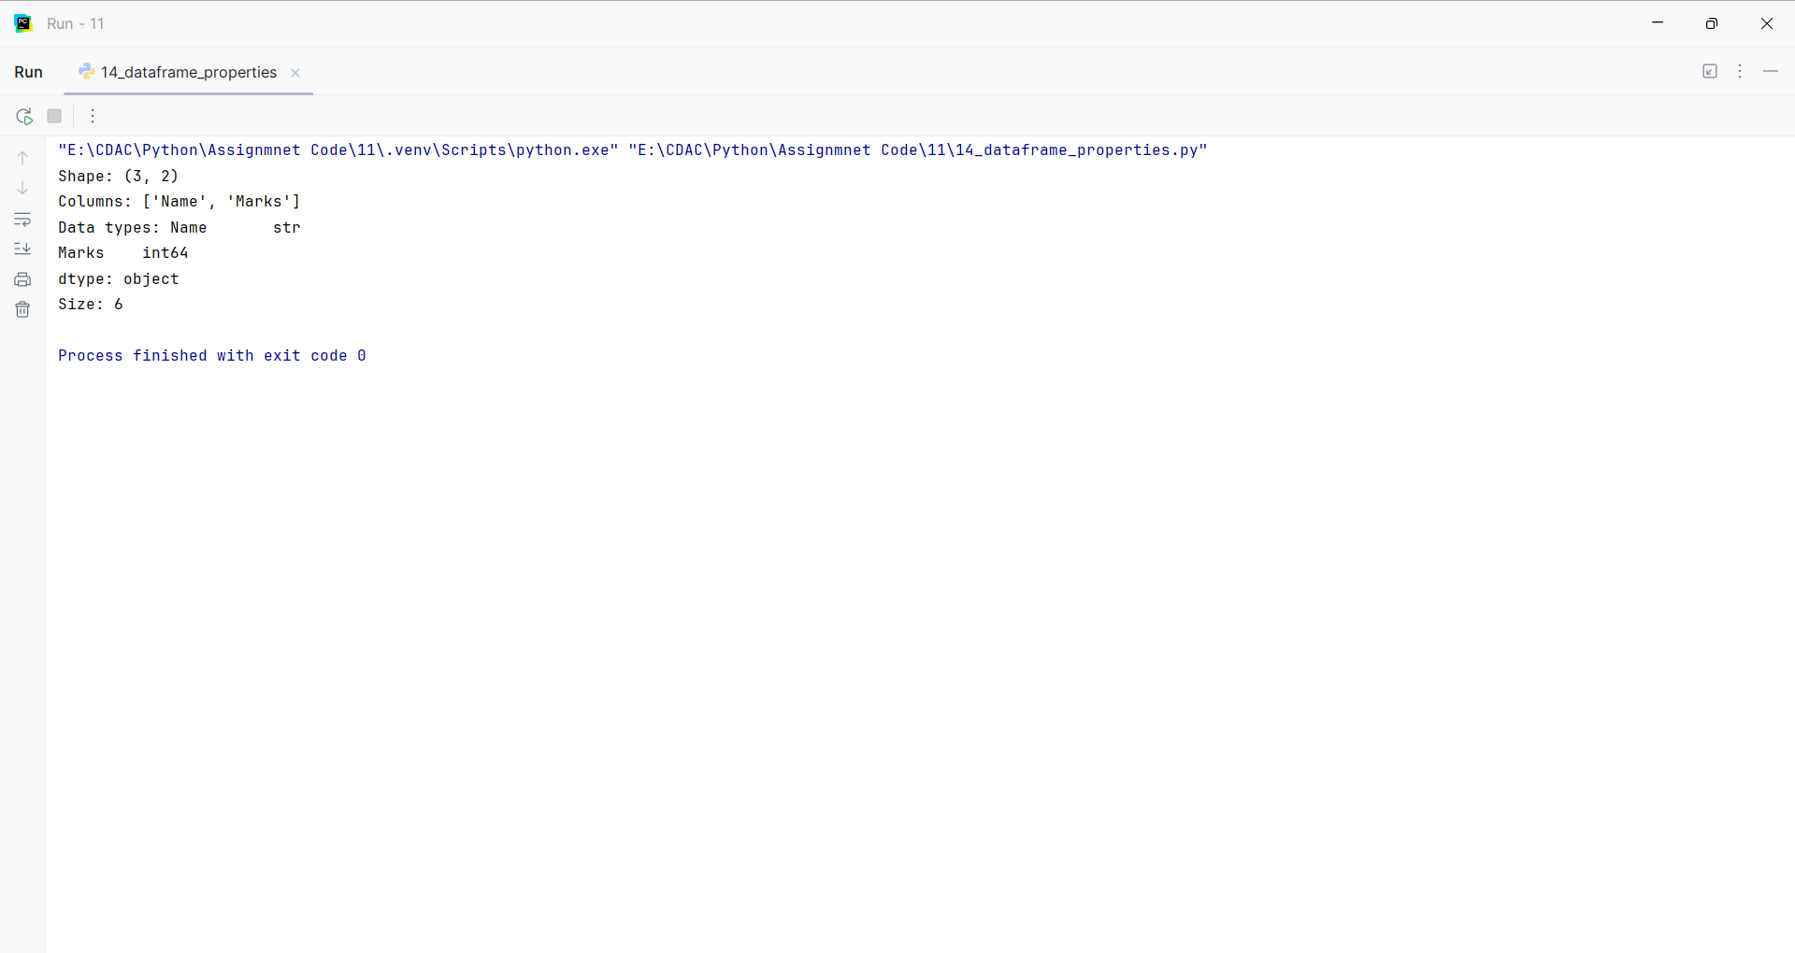
Question 15:
Create a student DataFrame and display students who have marks greater than 60.
Program
import pandas as pd
def filter_students():
df = pd.DataFrame({"Name": ["A", "B", "C", "D"], "Marks": [55, 72, 65, 48]})
return df[df["Marks"] > 60]
print(filter_students())

Input and Output
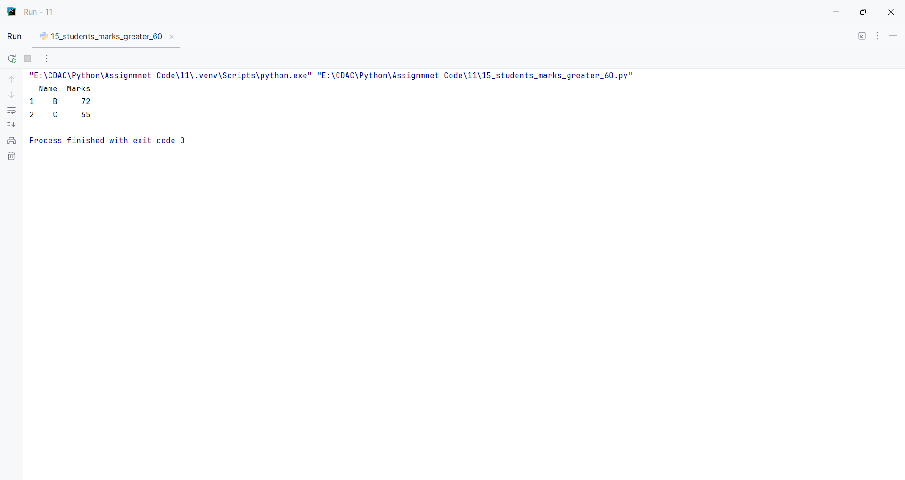
Question 16:
Create a DataFrame of employee salaries and find the maximum, minimum, and average salary.
Program
import pandas as pd
def salary_statistics():
df = pd.DataFrame({"Name": ["A", "B", "C"], "Salary": [40000, 55000, 70000]})
return df["Salary"].max(), df["Salary"].min(), df["Salary"].mean()
maximum, minimum, average = salary_statistics()
print("Maximum:", maximum)
print("Minimum:", minimum)
print("Average:", average)

Input and Output
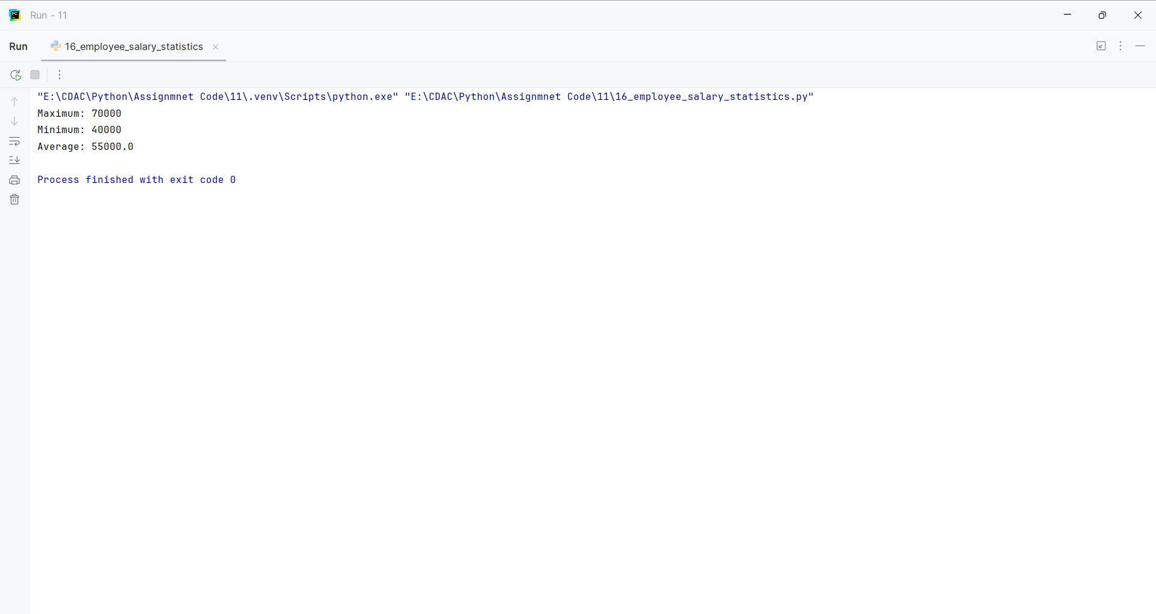
Question 17:
Create a DataFrame and use head() and tail() to display the first and last 5 records.
Program
import pandas as pd
def create_dataframe():
return pd.DataFrame({"Number": range(1, 11), "Value": range(10, 110, 10)})
df = create_dataframe()
print("First 5 records:")
print(df.head())
print("Last 5 records:")
print(df.tail())

Input and Output
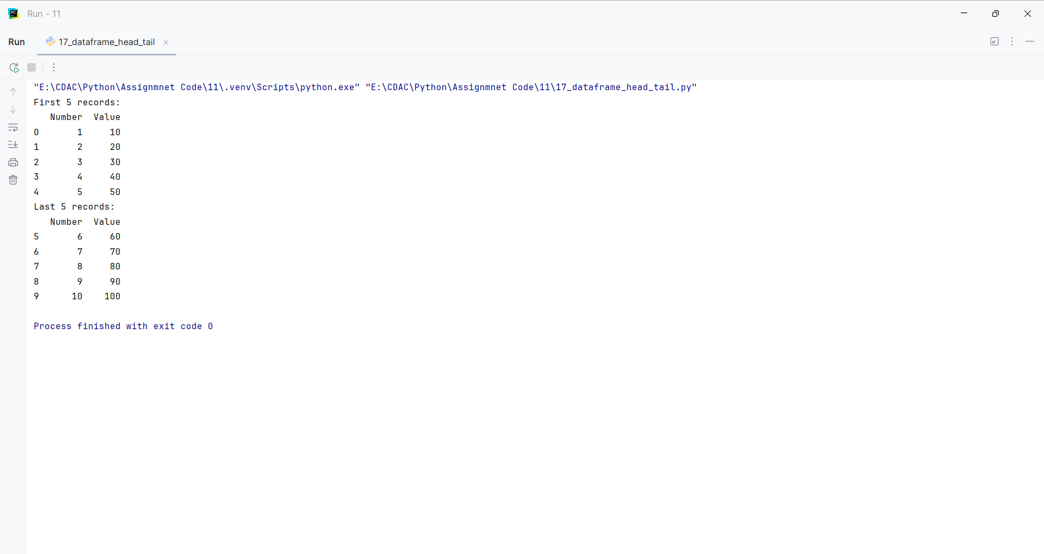
Question 18:
Create a DataFrame containing missing values and replace the missing values with an appropriate value.
Program
import pandas as pd
def fill_missing_values():
df = pd.DataFrame({"Name": ["A", "B", "C"], "Marks": [80, None, 90]})
return df.fillna({"Marks": 0})
print(fill_missing_values())

Input and Output
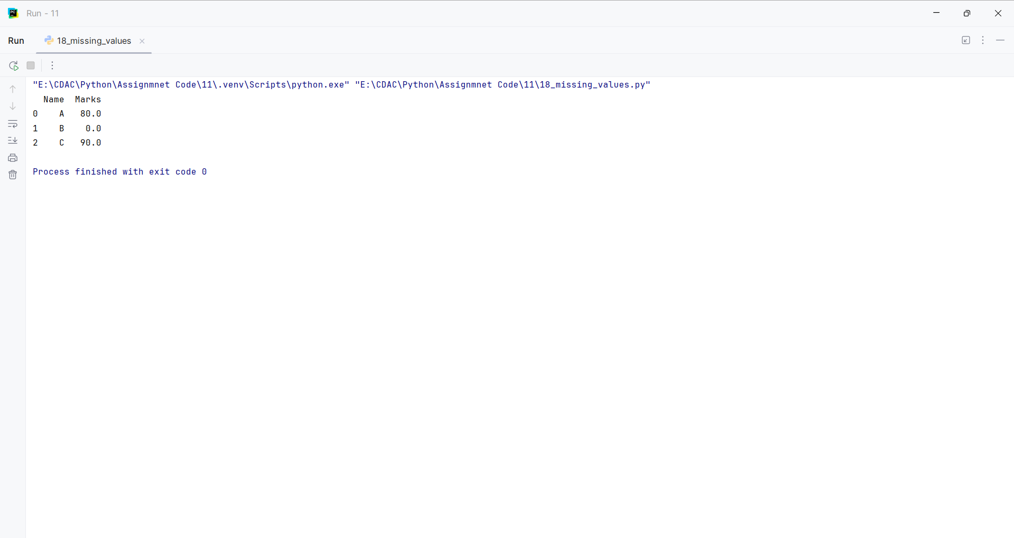
Question 19:
Create a student DataFrame and sort the students by marks in descending order.
Program
import pandas as pd
def sort_students():
df = pd.DataFrame({"Name": ["A", "B", "C"], "Marks": [70, 90, 80]})
return df.sort_values("Marks", ascending=False)
print(sort_students())

Input and Output
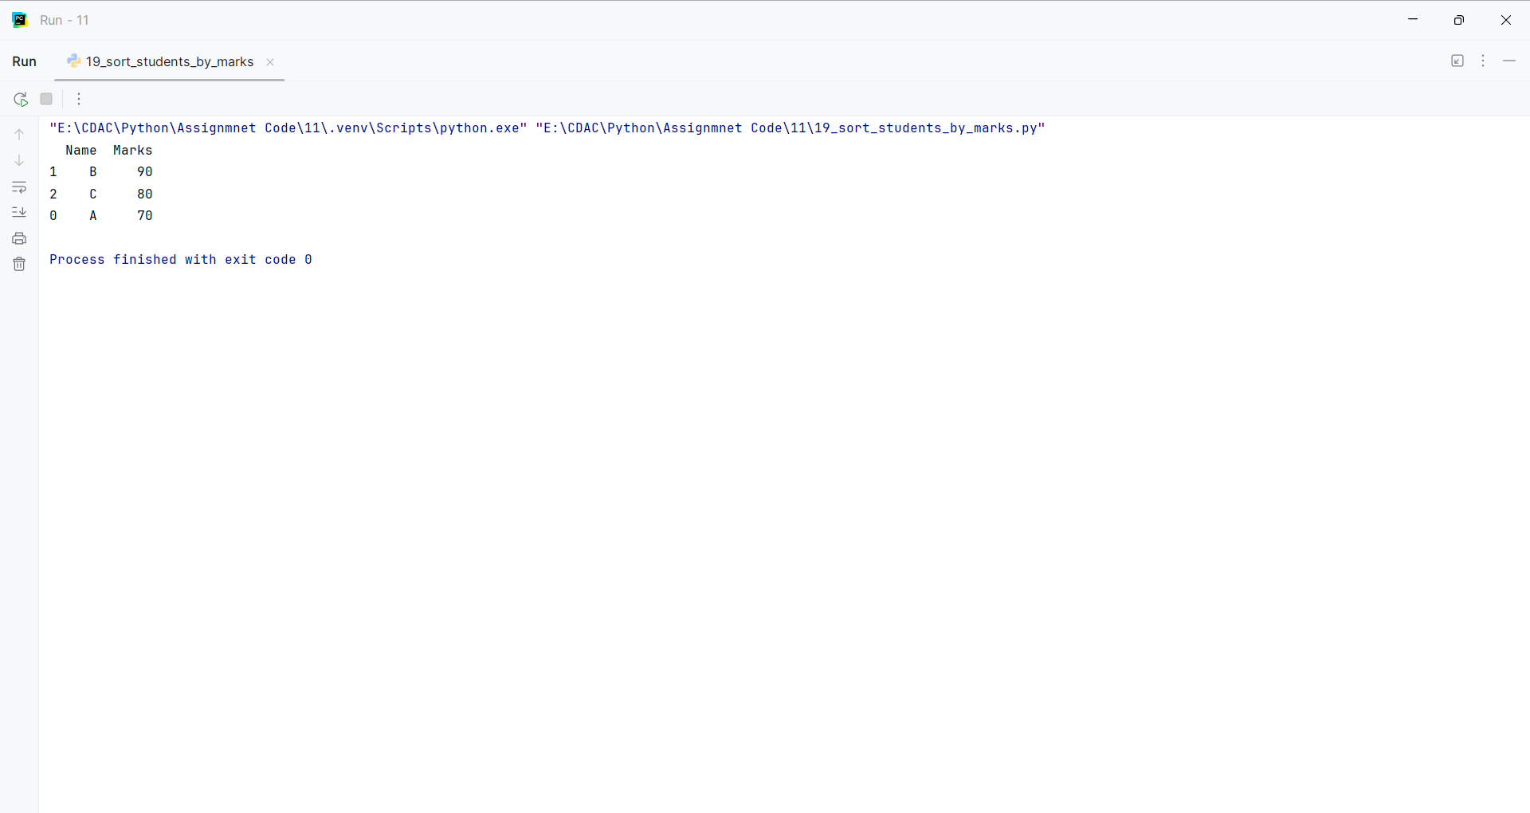
Question 20:
Create an employee DataFrame and group employees by department and calculate the average salary.
Program
import pandas as pd
def average_salary_by_department():
df = pd.DataFrame({"Name": ["A", "B", "C", "D"], "Department": ["IT", "HR", "IT", "HR"], "Salary": [60000, 50000, 70000, 55000]})
return df.groupby("Department")["Salary"].mean()
print(average_salary_by_department())

Input and Output
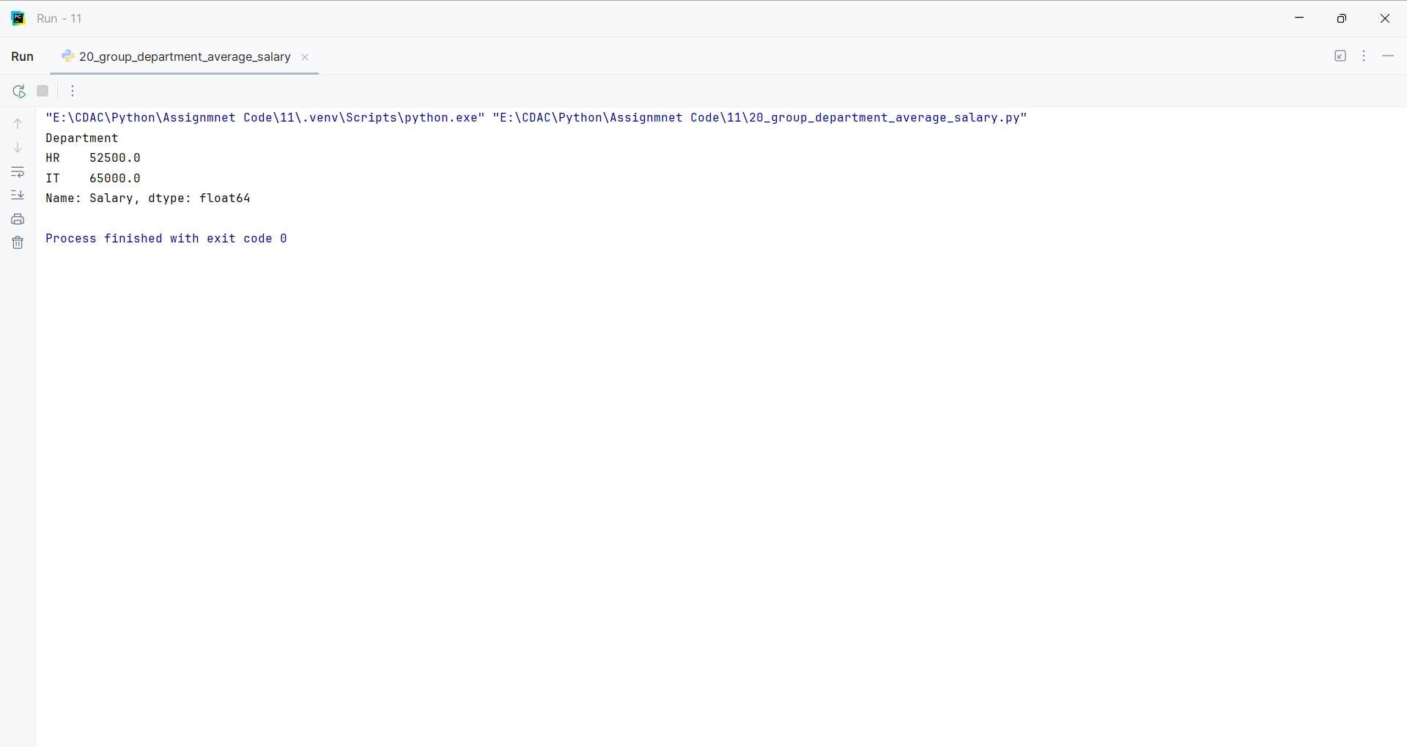
Question 21:
Create a DataFrame and use describe() to generate statistical information about the data.
Program
import pandas as pd
def create_dataframe():
return pd.DataFrame({"Marks": [65, 70, 80, 90, 75]})
df = create_dataframe()
print(df.describe())

Input and Output
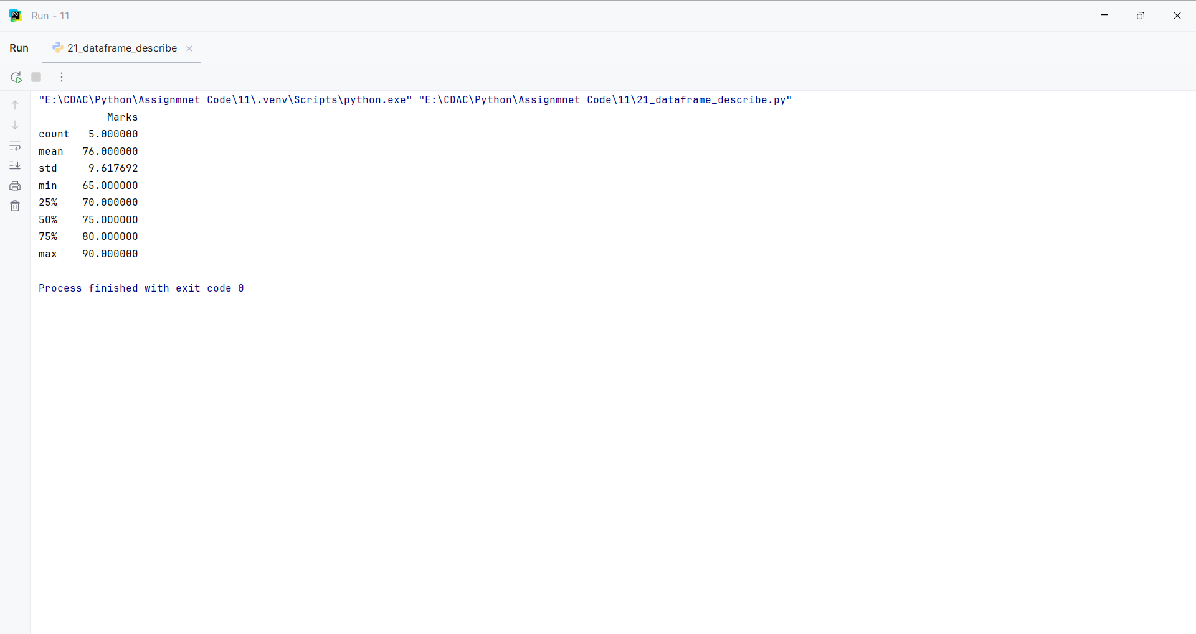
Question 22:
Create a DataFrame and rename two of its columns using Pandas.
Program
import pandas as pd
def rename_columns():
df = pd.DataFrame({"student_name": ["A", "B"], "student_marks": [80, 90]})
return df.rename(columns={"student_name": "Name", "student_marks": "Marks"})
print(rename_columns())

Input and Output
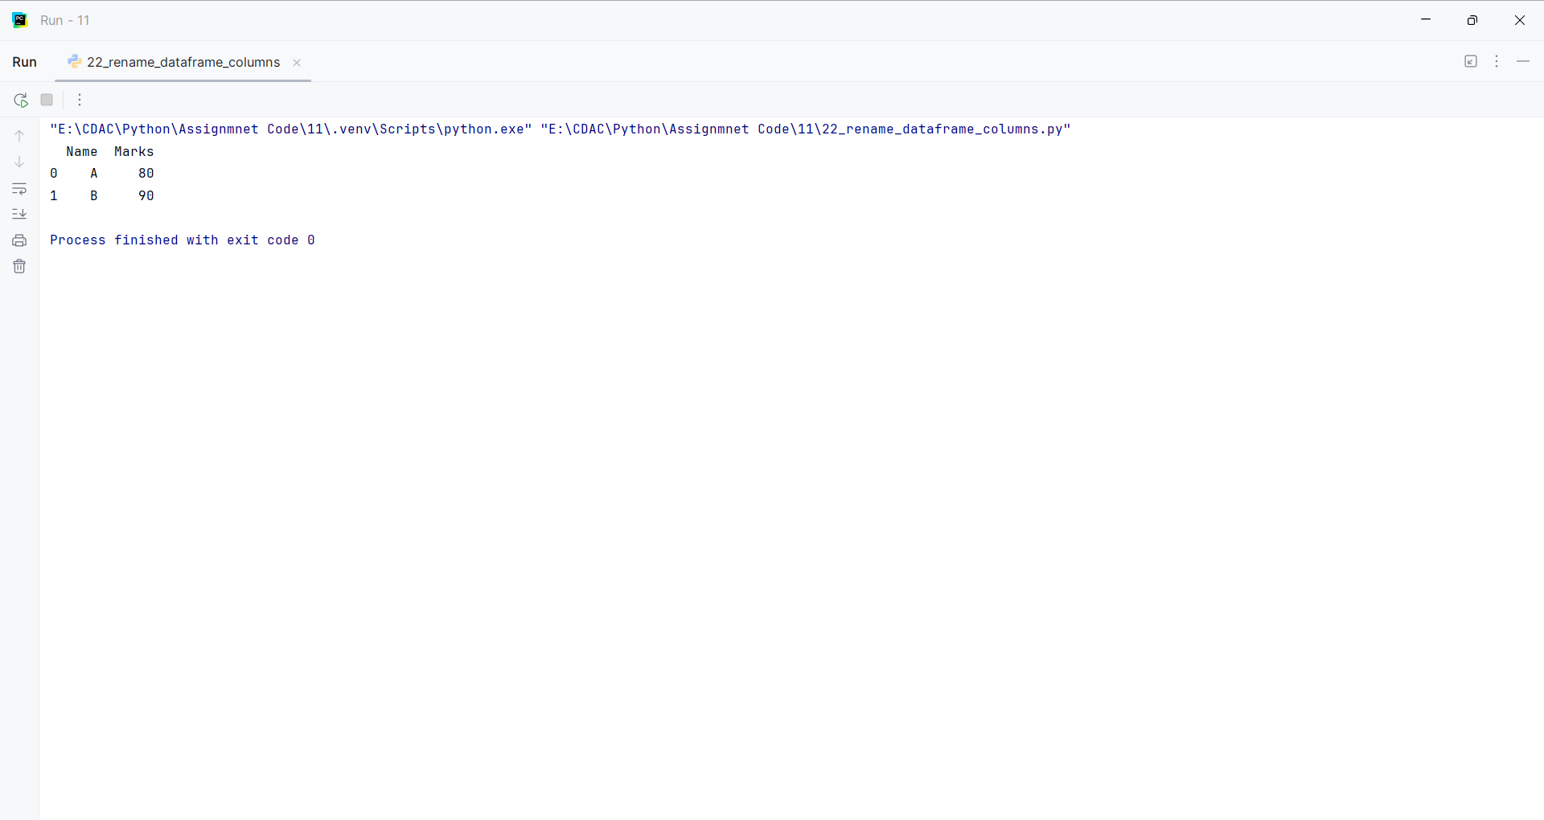
Question 23:
Create a DataFrame containing student marks and find the student with the highest and lowest marks.
Program
import pandas as pd
def highest_lowest_student():
df = pd.DataFrame({"Name": ["A", "B", "C"], "Marks": [75, 95, 60]})
return df.loc[df["Marks"].idxmax()], df.loc[df["Marks"].idxmin()]
highest, lowest = highest_lowest_student()
print("Highest:")
print(highest)
print("Lowest:")
print(lowest)

Input and Output
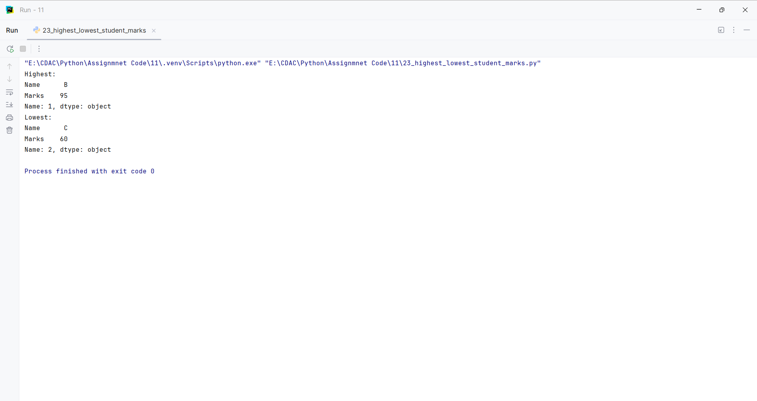
Question 24:
Create two DataFrames containing student information and merge them using a common column.
Program
import pandas as pd
def merge_dataframes():
first = pd.DataFrame({"ID": [1, 2, 3], "Name": ["A", "B", "C"]})
second = pd.DataFrame({"ID": [1, 2, 3], "Marks": [80, 90, 75]})
return pd.merge(first, second, on="ID")
print(merge_dataframes())

Input and Output
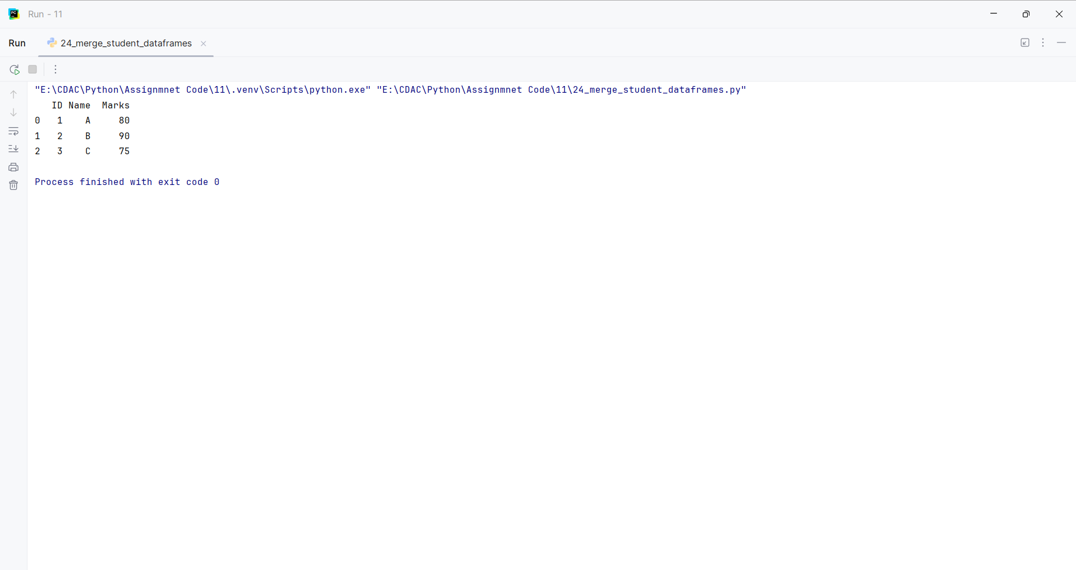
Question 25:
Create a DataFrame and remove a specified row and column.
Program
import pandas as pd
def remove_row_column():
df = pd.DataFrame({"Name": ["A", "B", "C"], "Marks": [80, 90, 70], "City": ["Pune", "Mumbai", "Nashik"]})
df = df.drop(index=1)
return df.drop(columns=["City"])
print(remove_row_column())

Input and Output
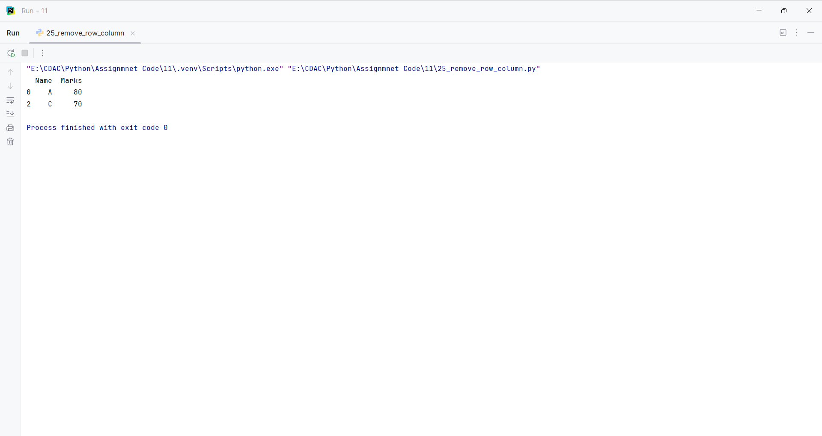
Question 26:
Create a DataFrame containing product details and calculate the total value using price × quantity.
Program
import pandas as pd
def calculate_total_value():
df = pd.DataFrame({"Product": ["Laptop", "Mouse", "Keyboard"], "Price": [50000, 500, 1500], "Quantity": [2, 10, 5]})
df["Total Value"] = df["Price"] * df["Quantity"]
return df
print(calculate_total_value())

Input and Output
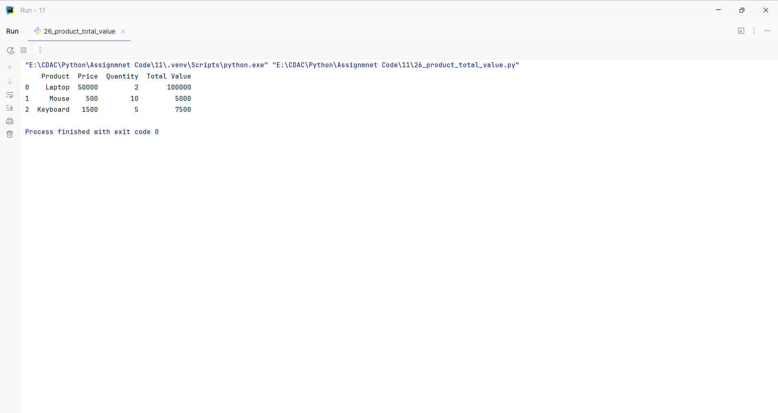
Question 27:
Create a DataFrame containing employee records and display employees belonging to a particular department.
Program
import pandas as pd
def filter_department():
df = pd.DataFrame({"Name": ["A", "B", "C"], "Department": ["IT", "HR", "IT"]})
return df[df["Department"] == "IT"]
print(filter_department())

Input and Output
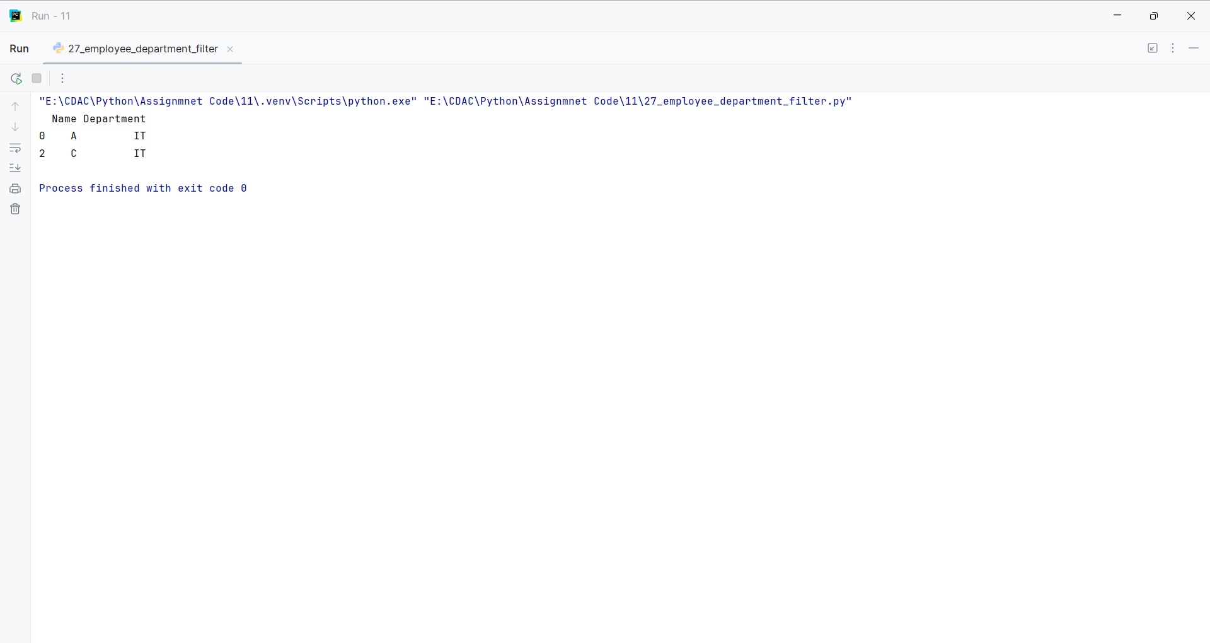
Question 28:
Create a DataFrame and use value_counts() to count the number of students in each course.
Program
import pandas as pd
def count_courses():
df = pd.DataFrame({"Name": ["A", "B", "C", "D", "E"], "Course": ["Python", "Java", "Python", "C++", "Python"]})
return df["Course"].value_counts()
print(count_courses())

Input and Output
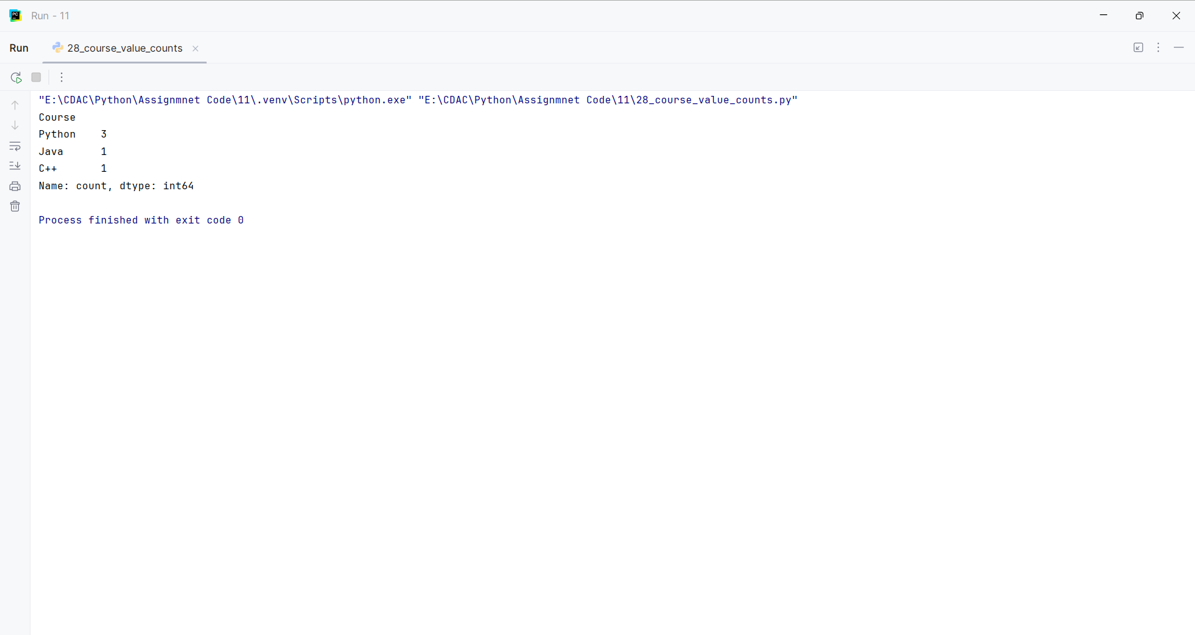
Question 29:
Create a DataFrame containing sales data and find the total sales for each product.
Program
import pandas as pd
def total_sales():
df = pd.DataFrame({"Product": ["A", "B", "A", "B"], "Sales": [100, 200, 150, 250]})
return df.groupby("Product")["Sales"].sum()
print(total_sales())

Input and Output
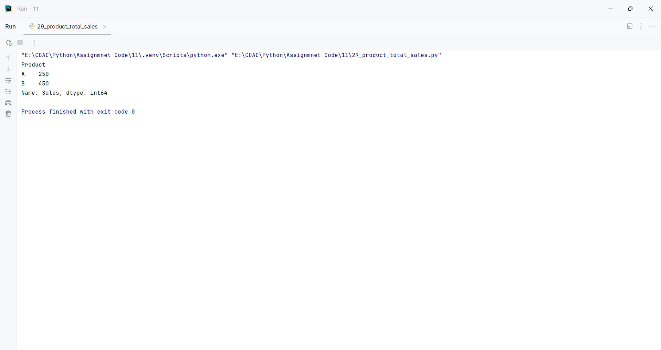
Question 30:
Create a DataFrame and save it to a CSV file, then read the CSV file using Pandas.
Program
import pandas as pd
def save_and_read():
df = pd.DataFrame({"Name": ["A", "B", "C"], "Marks": [80, 90, 70]})
df.to_csv("students.csv", index=False)
return pd.read_csv("students.csv")
print(save_and_read())

Input and Output
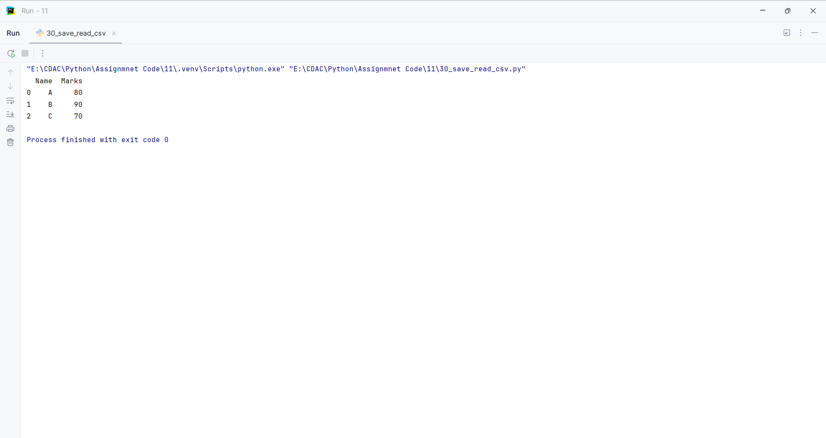
Question 31:
Create a DataFrame containing student records and perform filtering, sorting, grouping, and basic statistical analysis using Pandas.
Program
import pandas as pd
def analyze_students():
df = pd.DataFrame({"Name": ["A", "B", "C", "D"], "Course": ["Python", "Java", "Python", "Java"], "Marks": [80, 65, 90, 75]})
filtered = df[df["Marks"] > 70]
sorted_df = df.sort_values("Marks", ascending=False)
grouped = df.groupby("Course")["Marks"].mean()
statistics = df["Marks"].describe()
return filtered, sorted_df, grouped, statistics
filtered, sorted_df, grouped, statistics = analyze_students()
print("Filtered:")
print(filtered)
print("Sorted:")
print(sorted_df)
print("Grouped:")
print(grouped)
print("Statistics:")
print(statistics)

Input and Output
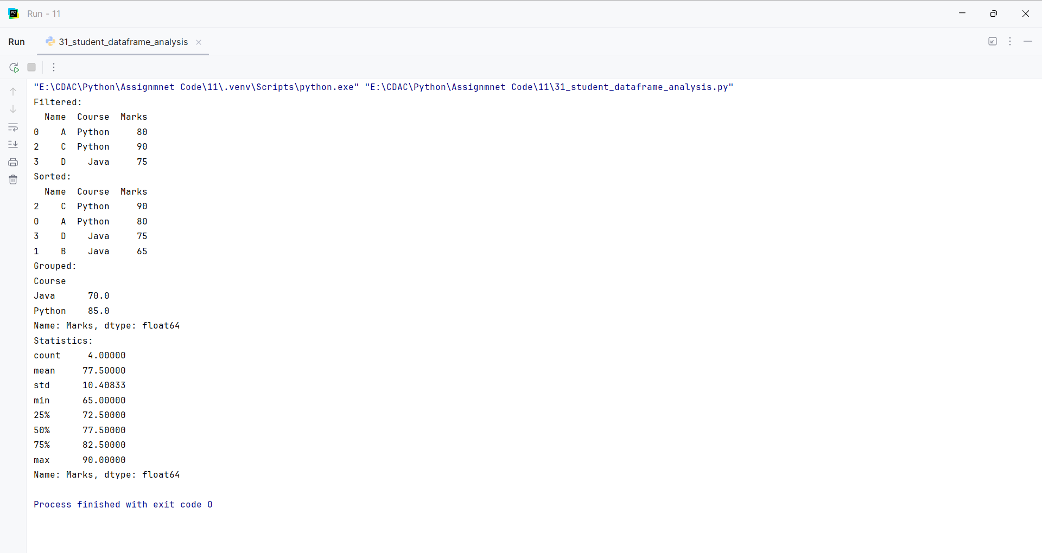
Question 32:
Create a database connection and perform CRUD operations.
Program
import sqlite3
def perform_crud():
connection = sqlite3.connect("assignment.db")
cursor = connection.cursor()
cursor.execute("CREATE TABLE IF NOT EXISTS students (id INTEGER PRIMARY KEY, name TEXT, marks INTEGER)")
cursor.execute("DELETE FROM students")
cursor.execute("INSERT INTO students (name, marks) VALUES (?, ?)", ("Pratik", 85))
cursor.execute("INSERT INTO students (name, marks) VALUES (?, ?)", ("Rahul", 90))
cursor.execute("SELECT * FROM students")
print(cursor.fetchall())
cursor.execute("UPDATE students SET marks = ? WHERE name = ?", (95, "Pratik"))
cursor.execute("DELETE FROM students WHERE name = ?", ("Rahul",))
cursor.execute("SELECT * FROM students")
print(cursor.fetchall())
connection.commit()
connection.close()
perform_crud()

Input and Output
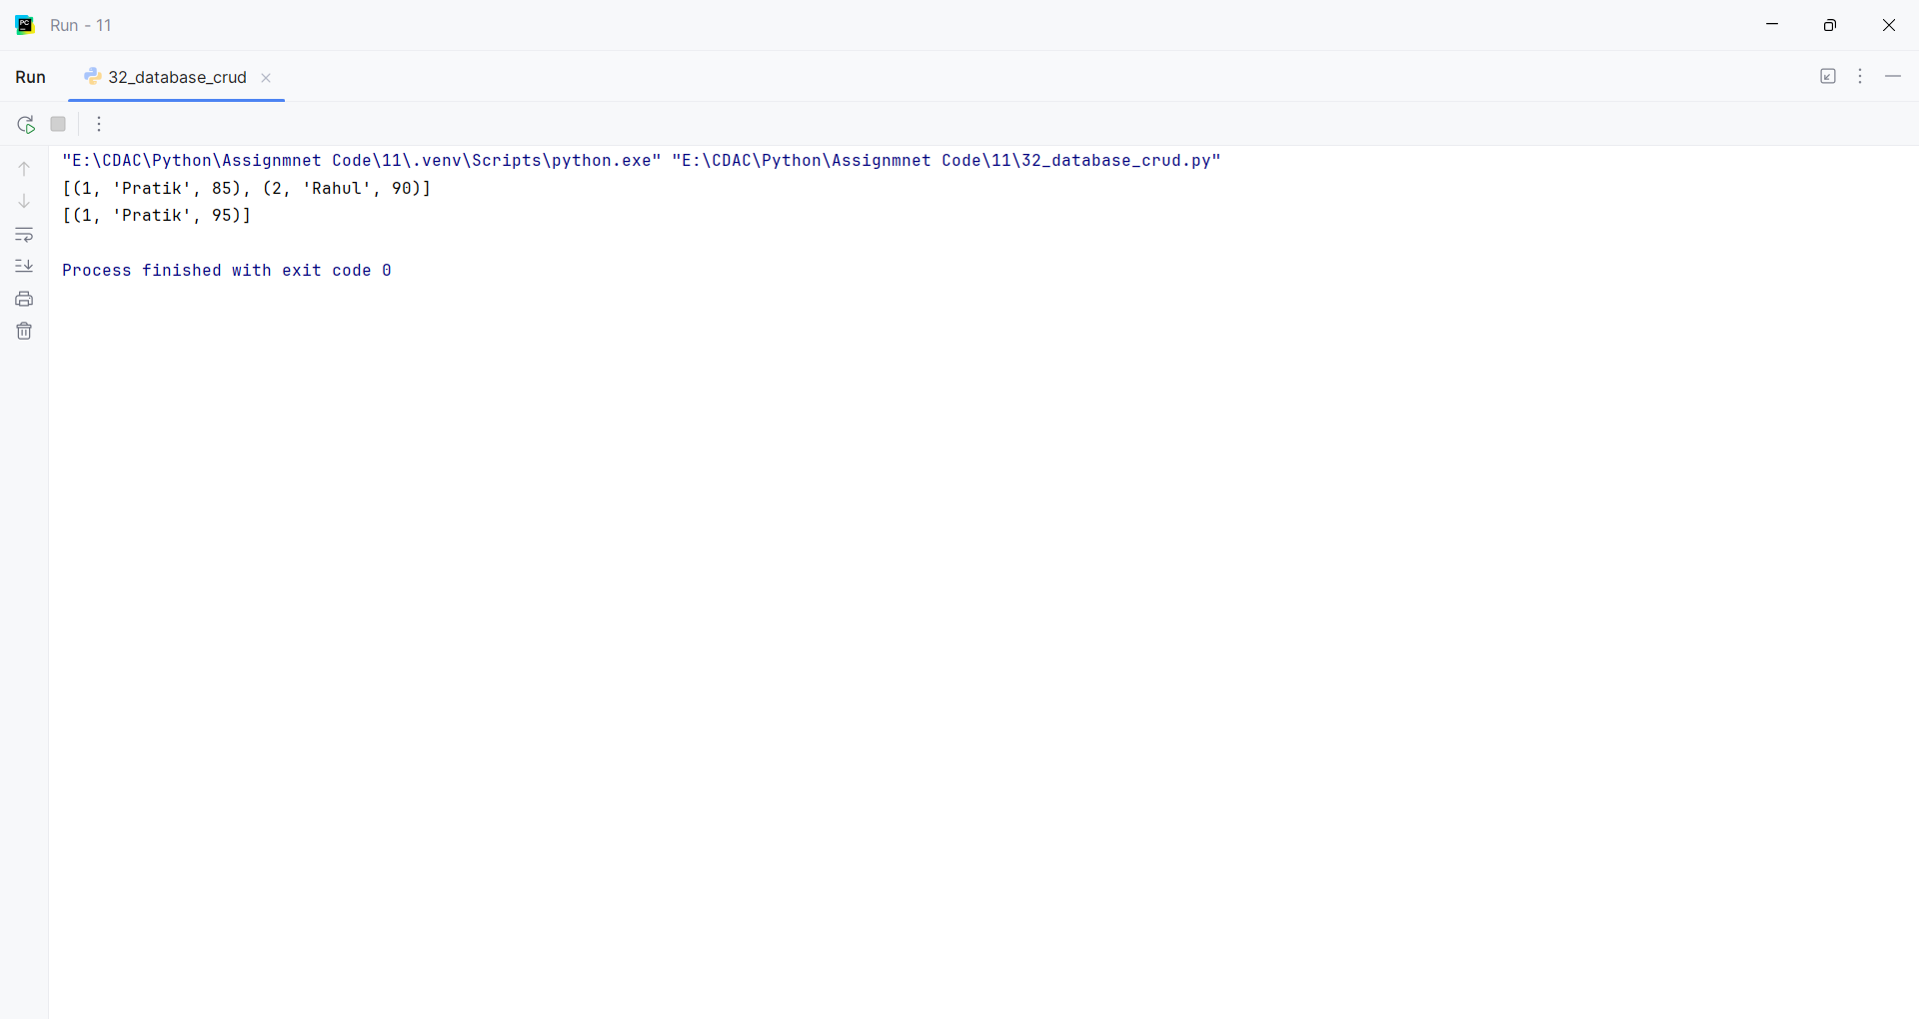
Question 33:
Practice with Matplotlib.
Program
import matplotlib.pyplot as plt
def create_plot():
months = ["Jan", "Feb", "Mar", "Apr", "May"]
sales = [100, 150, 120, 180, 200]
plt.plot(months, sales, marker="o")
plt.title("Monthly Sales")
plt.xlabel("Month")
plt.ylabel("Sales")
plt.show()
create_plot()

Input and Output
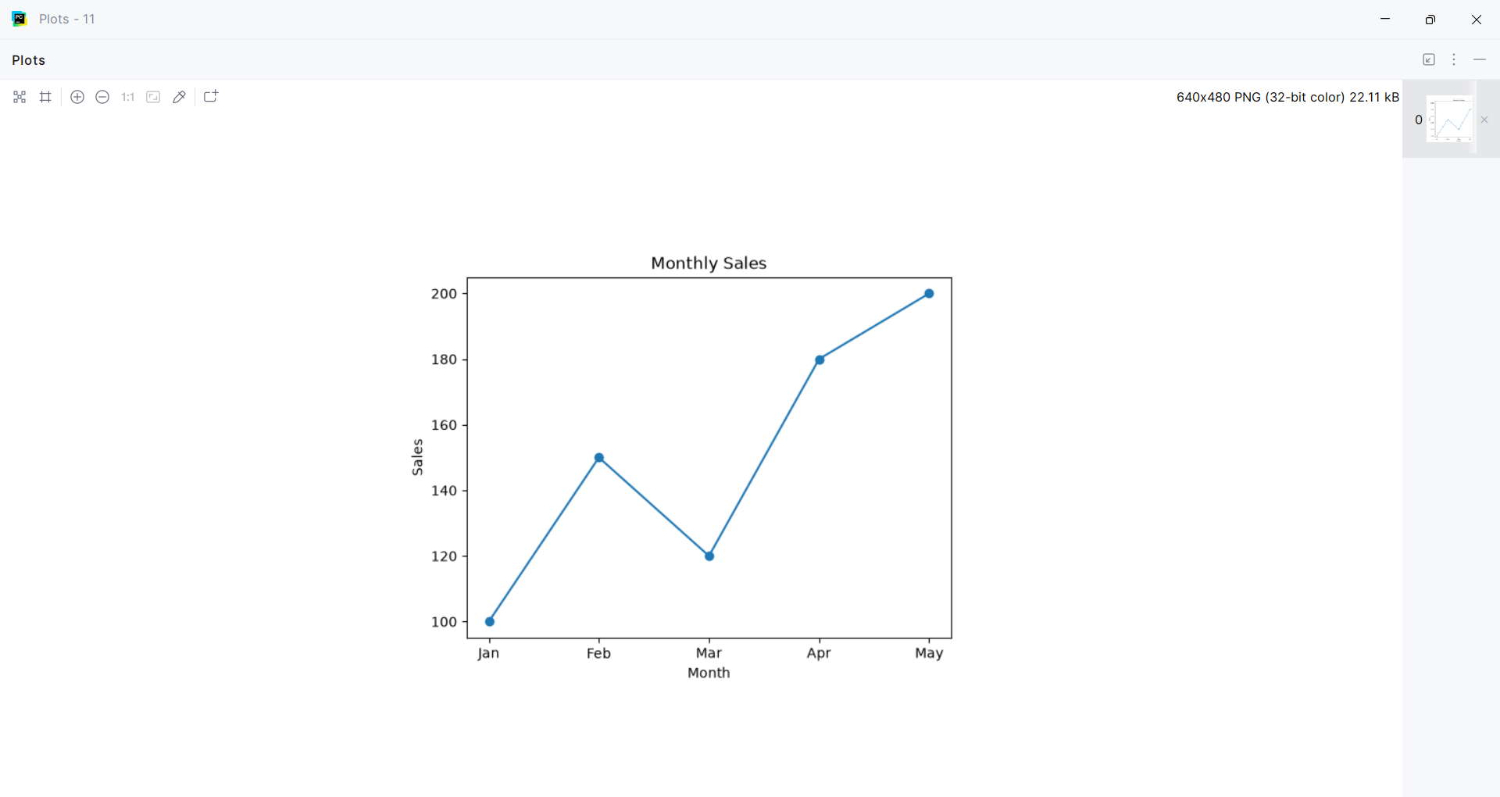
Question 34:
Practice with Seaborn.
Program
import seaborn as sns
import matplotlib.pyplot as plt
def create_plot():
data = {"Marks": [65, 70, 75, 80, 85, 90, 95]}
sns.histplot(data["Marks"], bins=5)
plt.title("Marks Distribution")
plt.show()
create_plot()

Input and Output
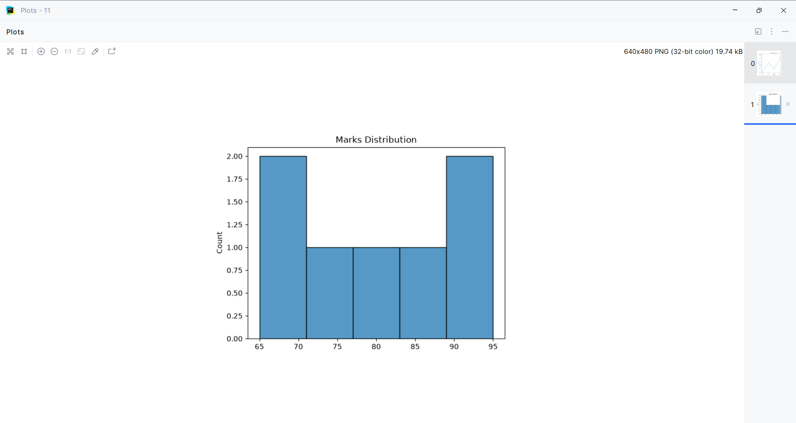
Question 35:
Practice with Tkinter.
Program
import tkinter as tk
def create_window():
window = tk.Tk()
window.title("Tkinter Practice")
window.geometry("300x150")
label = tk.Label(window, text="Hello, Tkinter!")
label.pack(pady=20)
button = tk.Button(window, text="Close", command=window.destroy)
button.pack()
window.mainloop()
create_window()

Input and Output
